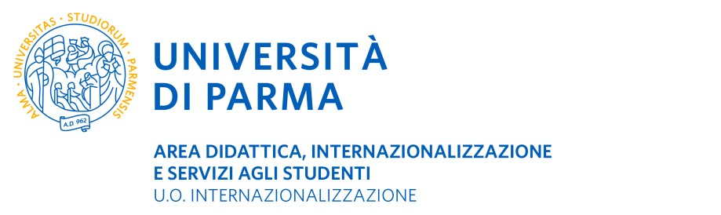

Summer School Academic Year 2022-2023
CERTIFICATE OF ARRIVAL AT HOST INSTITUTION
TO BE SENT WITHIN 5 DAYS FROM THE ARRIVAL DATE (to be scanned and sent by e-mail) TO:
U.O. Internazionalizzazione – Erasmus and International Home P.le San Francesco, 3 – 43121 Parma – Italia erasmus@unipr.it

It is hereby certified that (name of student), coming from the University of Parma (I PARMA01) arrived at (name of Host Institution), ERASMUS+ code (if applicable) on (date) / / (dd/mm/yyyy).

The student intends to complete the Summer school titled:
Type of mobility (please tick as appropriate):

PHYSICAL MOBILITY from / / to / / (dd/mm/yyyy) (dd/mm/yyyy)
BLENDED MOBILITY (may attend a mix of classes in person and online)
The physical mobility period will be from / / to / /
(dd/mm/yyyy) (dd/mm/yyyy)
The virtual mobility period will be from / / to / /
(dd/mm/yyyy) (dd/mm/yyyy)

VIRTUAL MOBILITY (attend online classes from their home in their home country)
The virtual mobility period will be from / / to / /
(dd/mm/yyyy) (dd/mm/yyyy)

Date ____________________
Signature of the officer in charge of the Summer School

Stamp of host institution

at host institution

_____________________________

