SEMINARIO

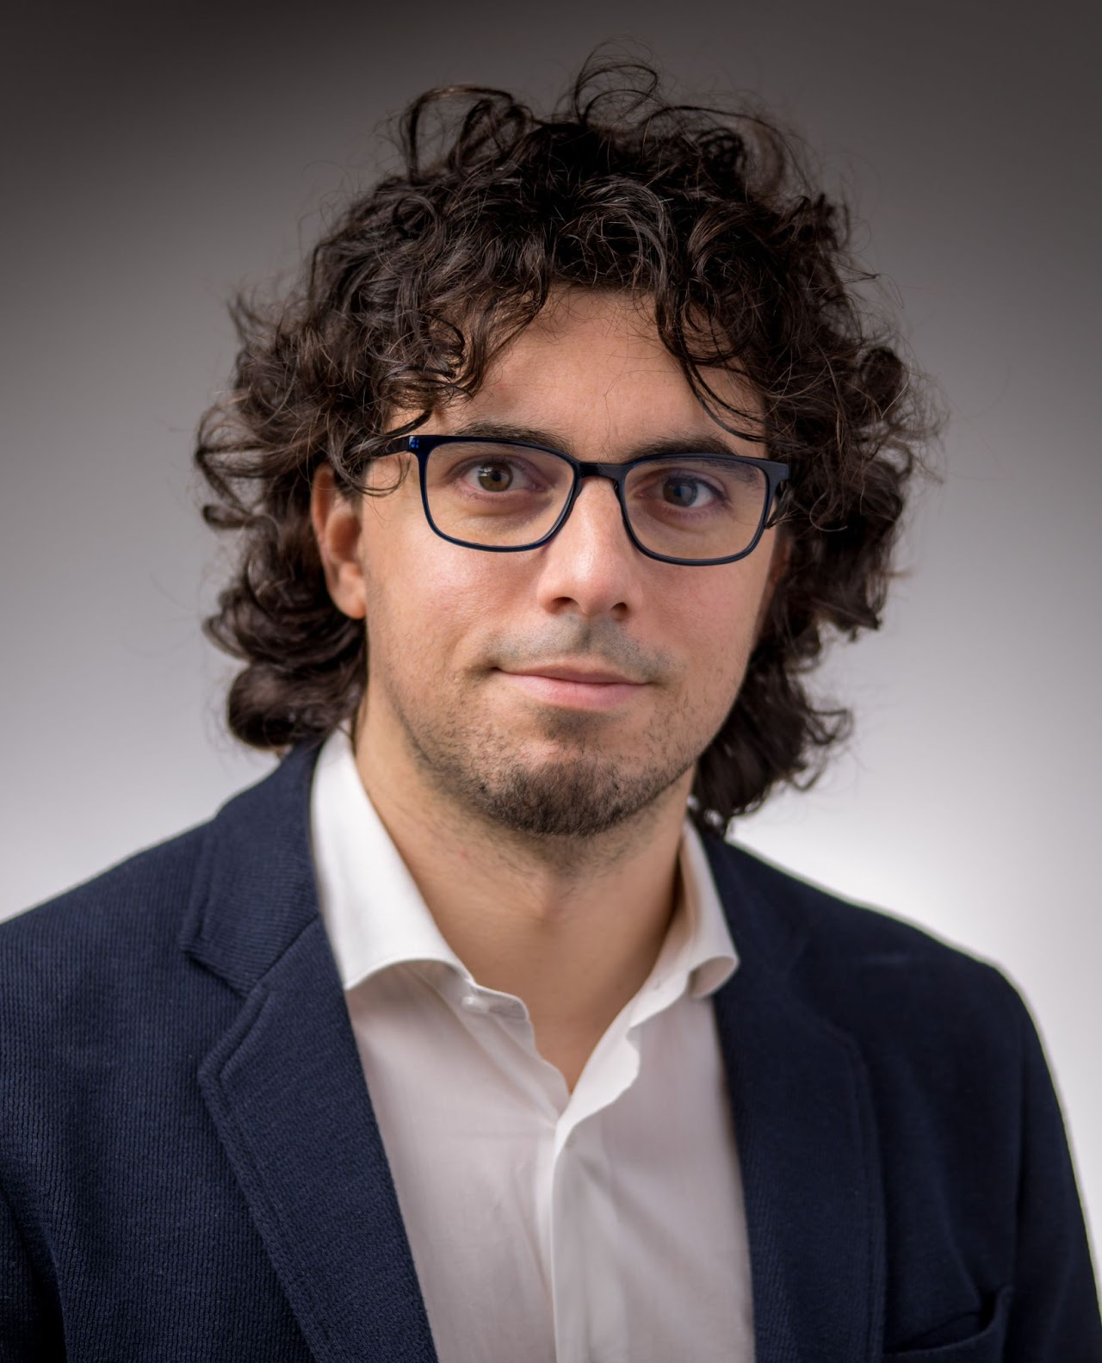
Marco Radeschi,

Professore Associato, Università di Torino

Martedì 31 Aprile 2026 ore 14.00

Sala Riunioni e Seminari, Plesso di Matematica

Titolo: Invariant theory, without groups

Sunto: I will define, contextualize and discuss the concept of manifold submetry, which generalizes classical concepts like Riemannian submersions or isometric group actions. The goal is to give a panoramic view of recent results about manifold submetries in compact homogeneous spaces, connecting algebra, geometry and analysis to establish a dictionary between the geometry of submetries and the algebraic properties of their algebraic counterparts. This correspondence generalizes Classical Invariant Theory, but has nicer properties that can be exploited to actually obtain new results, even in Classical Invariant Theory itself.

Organizzatore: Prof. Leonardo Biliotti

