ALLEGATO 5

BANDO DI ATENEO PER LO SVILUPPO DI NETWORK DI RICERCA INTERNAZIONALI 2026
Table 1: Country correction coefficients (CCC) for Doctoral Networks and Postdoctoral Fellowships living allowances - Horizon Europe - Work Programme 2026-2027 Marie Skłodowska

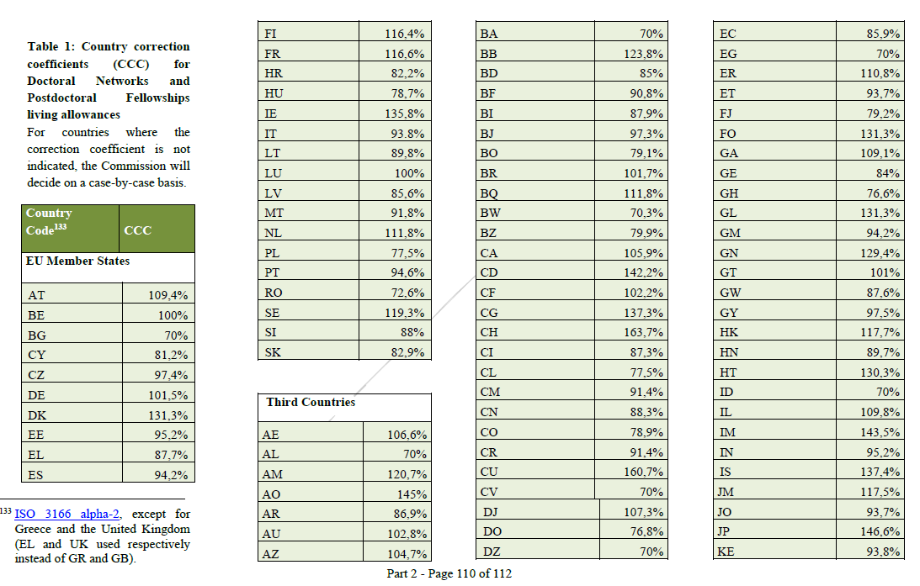

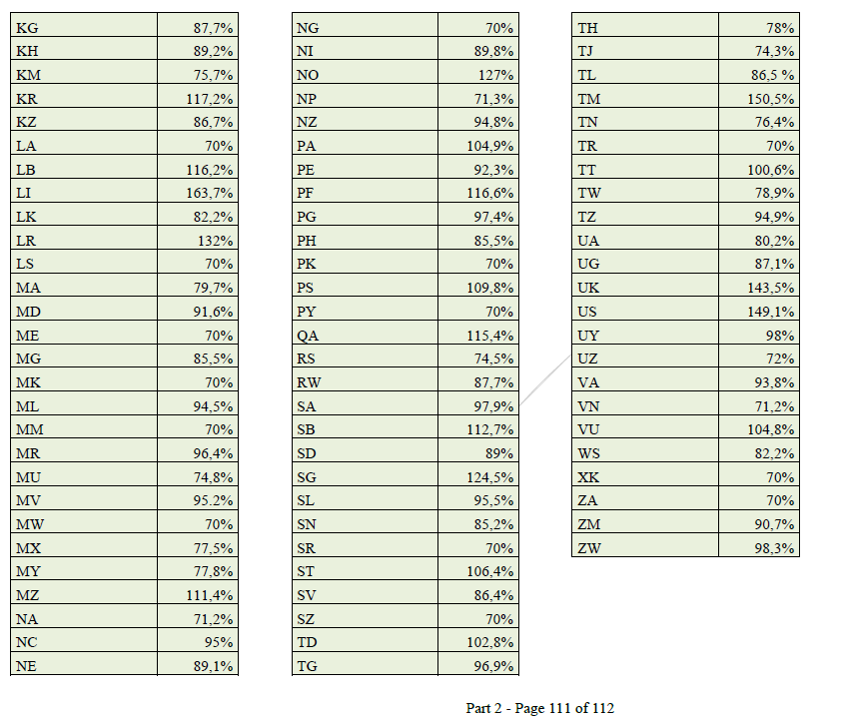

For countries where the correction coefficient is not indicated, the evaluation committee (art. 7) will decide on a case-by-case basis

